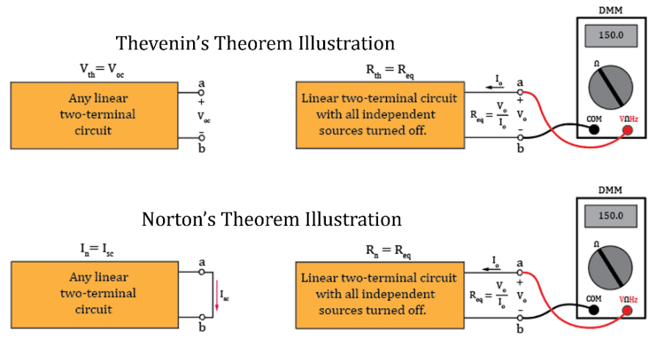
ECEN 350 – Equation Sheet 1 (9/09/2024)
$$Capacitor Impedance: Z_{C}=X_{C}∠\left(-90˚\right)=-jX_{C}, with X_{C}=1/{ωC}=1/{2πfC}.$$
$$Inductor Impedance:Z_{L}=X_{L}∠90˚=jX_{L},with X_{L}=ωL=2πfL.$$
Power P = VI = I²R = V²/R. Average AC Power P = $V_{rms}I_{rms}\cos\left(θ\right).$
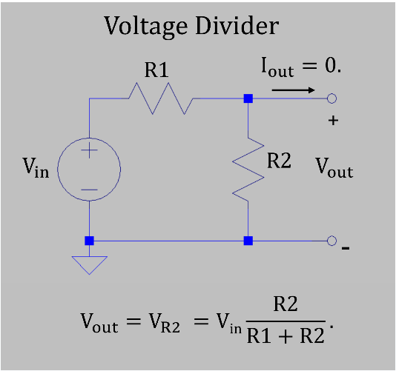
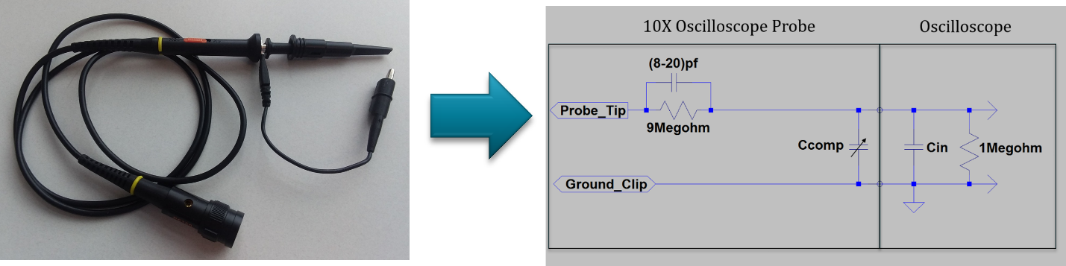
$$Shockley Diode Equation: I_{D}=I_{S}\left(e^{{V_{D}}/{nV_{T}}}-1\right) A, where I_{S} is the reverse saturation$$
$current, V_{D} is applied voltage across the$Diode, V_{T} is referred to as the thermal voltage, and n is an ideality factor ranging from 1 – 2. Assume n = 1 for ECEN 350.
Thermal Voltage: $V_{T}=\frac{kT_{k}}{q}, where \text{k=}1.38×{10}^{-23} J/K\text{ is Boltzmann’s constant,}$ T_{K} is the temperature in Kelvin, and q = $1.6×{10}^{-19} C$ is the magnitude of the charge of an electron or proton. $V_{T}≈25 mV @ 20 ˚C$.
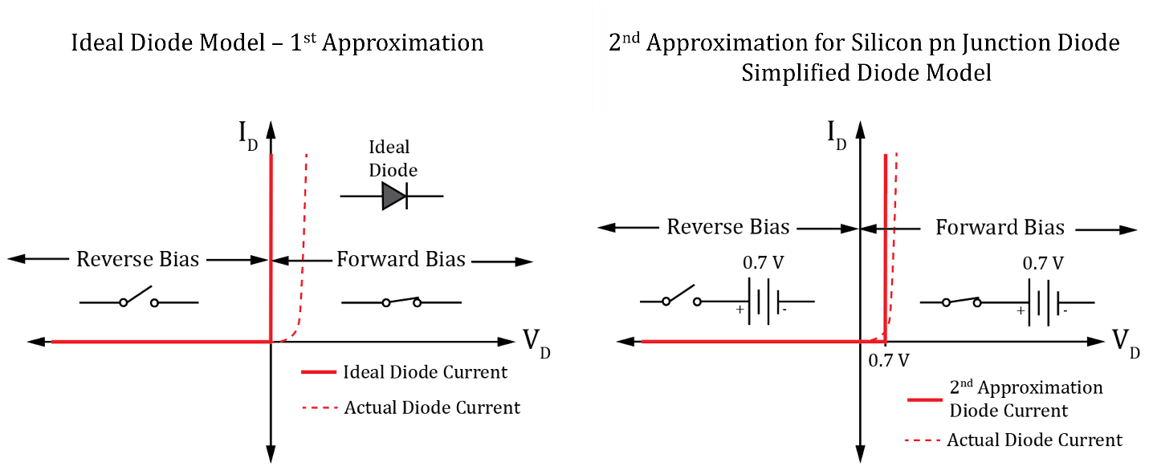
Junction Temperature: T_{J} = T_{A} + ∆T_{J} = T_{A} + PR_{θJA}. T_{J} = T_{A} + PR_{θJA}, where T_{A} is the ambient temperature, P is the power dissipated, and R_{θJA} is the thermal resistance in ˚C/W.
$$Diode DC Forward Resistance, R_{F}=\frac{V_{D}}{I_{D}}. Diode Bulk Resistance, R_{B}=\frac{{∆V}_{D}}{{∆I}_{D}}.$$
